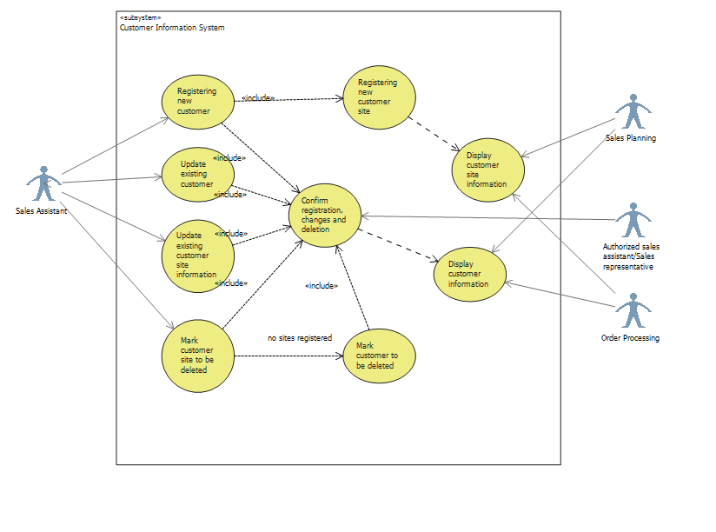

|  |  |
| --- | --- |
| Use Case | Display customer information |
| Actor: | Sales Planning subsystem/Order processing subsystem |
| Pre condition: | Sales Planning case: There is a need in a regular planning routine. The analysis requires displaying customer information on the screen for utilizing it for performing researches. Customers’ information is stored in the system and is available to be displayed. |
| Goal: | The acquired information about a customer is utilized for sales planning analysis. |
| 1 | The actor selects a customer according to the actor’s needs. |
| 2 | The customer information is displayed on the screen: company name, invoicing and delivery address, contact person information, way of delivery and other possible information. |
| 3 | The actor chooses the desired information for research and processes it according to corresponding subsystem architecture and needs. |

|  |  |
| --- | --- |
| Use Case | Display customer site information. |
| Actor: | Sales Planning subsystem/Order processing subsystem |
| Pre condition: | Sales Planning case: There is a need in a regular planning routine. The analysis requires acquiring customer information on the screen for utilizing it for performing researches. Customer sites’ information is stored in the system and is available to be displayed. |
| Goal: | The acquired information about a customer site is utilized according to particular actor’s requirements. |
| 1 | The actor selects a customer site according to corresponding subsystem architecture and the actor’s needs. |
| 2 | The customer site information is displayed on the screen: company name, invoicing and delivery address, contact person information, way of delivery and other possible information. |
| 3 | The actor chooses the desired information for research and processes it according to corresponding subsystem needs. |